**System Requirements Specification**

**for**

**Portable Ultrasound Device for Coda-Wave Interferometry**

**Version 1.8**

**Prepared by Michael Kisellus**

**Christopher Coppedge**

**Layton Foxworthy**

**Matthew Baker**

**Kyle Fox**

**13APR2024**

**Table of Contents**

**Table of Contents ii**

**Revision History ii**

**1. Introduction 4**

1.1 Purpose 4

1.2 Document Conventions 4

1.3 Intended Audience and Reading Suggestions 4

1.4 Product Scope 4

1.5 References 5

**2. Overall Description 5**

2.1 Product Perspective 5

2.2 Product Functions 6

2.3 User Classes and Characteristics 6

2.4 Operating Environment 7

2.5 Design and Implementation Constraints 7

2.6 User Documentation 7

2.7 Assumptions and Dependencies 8

**3. External Interface Requirements 8**

3.1 User Interfaces 8

3.2 Hardware Interfaces 9

3.3 Software Interfaces 10

3.4 Communications Interfaces 10

**4. System Features 10**

4.1 System test pulse generation and reception 10

4.2 System self-regulation/ protection for overheat 11

4.3 System alarm system 12

4.4 After test processing 13

**5. Other Nonfunctional Requirements 13**

5.1 Performance Requirements 13

5.2 Safety Requirements 13

5.3 Security Requirements 14

5.4 System Quality Attributes 14

5.5 Business Rules 14

**6. Other Requirements 14**

**Appendix A: Glossary 14**

**Appendix B: Analysis Models 15**

**Appendix C: Reference 16**

**Revision History**

|  |  |  |  |
| --- | --- | --- | --- |
| **Name** | **Date** | **Reason For Changes** | **Version** |
| Michael Kisellus, Christopher Coppedge, Layton Foxworthy, Matthew Baker, Kyle Fox | 1Feb | Initial draft | 1.0 |
| Matthew Baker | 1 Feb | Initial draft, initial edit | 1.1 |
| Michael Kisellus | 4Feb | Figure 3,5 update, Times new roman text, removed appendix D, updated table of contents, update appendix c | 1.2 |
| Christopher Coppedge | 2/22 | Making changes based on TA feedback | 1.3 |
| Michael Kisellus | 29Feb | Same as above | 1.4 |
| Christopher Coppedge | 3/21 | Making changes based on TA feedback | 1.5 |
| Michael Kisellus | 21Mar | correcting req 4.1.3.1 | 1.6 |
| Matthew Baker | 31Mar | Making changes based on TA feedback | 1.7 |
| Christopher Coppedge | 4 April | Final changes and review | 1.8 |

# Introduction

Bridges are vital transportation infrastructure that are used daily by millions of people. Like any constructed work, the material used has a finite lifespan and will degrade as both the effects of nature and its designed purpose act on the bridge. Being able to determine locations of failure points, subsurface cracks, and voids in building materials such as concrete can greatly increase the ability for an engineering team to predict future issues and plan remedial work for a bridge. To assist those engineers, the Portable Ultrasound Device (PUD) was designed. This device can be used in conjunction with ultrasonic transducers to detect anomalies within concrete. The data collected can be used to make future engineering decisions.

## Purpose

This document intends to define all requirements and conditions relating to the Portable Ultrasound Device. This document covers the physical device hardware, software required to operate the device, operator interaction with the device and the requirements used to produce the unit. As well as software used to process the data collected by the unit (if applicable).

## Document Conventions

Document is in keeping with the provided template, no other requirements exist for this document specific to this project.

## Intended Audience and Reading Suggestions

The intended user for this product is civil engineers and maintenance workers responsible for the integrity of bridge support pillars. This also applies for any profession working with or testing load bearing concrete support pillars such as inspectors or safety personnel. This document contains information on product functionality and requirements given by the client Dr. Brown. Section 2 contains an overall view of the project. Section 3 contains information and procedures for how to use the product. This would be most useful to a system operator or troubleshooter. Section 4 and 5 contain features and operational requirements for the system.

Section 1.4 contains any references used and is required to fully understand or troubleshoot the device.

## Product Scope

The goal of this system is to provide bridge maintenance and safety workers with a field service tool to detect crack propagation. This will allow the operator to gather data over the course of 72 hours and make a more accurate determination of the bridged pillars structural integrity and therefore make the bridge safer for all its users.

Produce a field service unit which after being placed to measure a concrete section will collect data over the course of 48 to 72 hours and be retrieved to review the collected data. The unit will be light enough for one person to move (less than 50 pounds), weather resistant and durable enough for field work.

## References

Appendix C contains the references used for the PUD project.

# Overall Description

Section 2 covers the project's purpose is section 2.1, product functions in section 2.2, user information in section 2.3, and description of the operating environment in section 2.4. Sections 5,6, and 7 contain constraints, user documentation and assumptions made for the unit.

## Product Perspective

The Portable Ultrasound Device for Coda-Wave Interferometry is a new, self-contained product that assists in the internal inspection of concrete support pillars. The system consists of a standalone unit for measuring and recording a concrete sample response to a transducer generated wave.

Figure 1 displays the overhead view of the system. Starting at point 1 a 500v 2 microsecond pulse is produced by the PUD. The transducer then vibrates at 54kHz and enters the concrete test sample shown at point 2. At point 3 the signal that has traveled through the concrete is received at a 2nd transducer and sends an electrical signal to the PUD shown as point 4.

Figure 1: overall system diagram for portable ultrasound device (PUD)

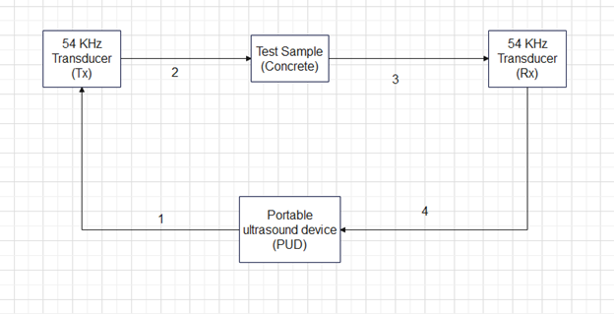

Figure 2: Portable ultrasound device(PUD) hardware diagram <removed, rev1.4>

## Product Functions

### The following section provides a list of the major functions the product must perform

### Generate a test pulse to the transistor transmitter (TX).

### Receive response signal from the transistor receiver (Rx)

### Store the received data locally (SD card)

### Process raw data offsite using computer programs.

### Monitor and maintain device functionality for an extended period of time.

## User Classes and Characteristics

### Data analyst

### The Data analyst will receive the raw data from the receiving transducer. The raw data consists of voltages over time, which are then graphed and analyzed. The data analyst then makes the determination if there is interior structural damage. If the results are inconclusive then the data analyst can request the test engineer to take another sample or reposition the test transducer positions.

### Test engineer

The test engineer will be responsible for going into the field and performing transducer placement to perform the test. Activating the unit to collect data, then retrieving the unit 48 to 72 hours after test initiation.

## Operating Environment

### User interface

The user will interface with the device through a panel of push buttons, and electrical isolation switches. The user will have a panel of LEDs to show the PUD’s condition/status . Because the interface is physical it will require no exterior programs to function during testing.

### Data processing

The data saved during testing is saved on a Secure Digital (SD) card using .mat format (other formats may be considered but currently the civil engineering lab is using .mat). Requiring the user to possess a window 10 or later operating software. Python, possibly C (if lower level coding is required) and MATLAB programs are required to operate the analysis software.

## Design and Implementation Constraints

### *Design constraints*

**2.5.1** The unit shall not exceed 50 pounds.

**2.5.2** The unit shall be smaller than 30” x 30” x 20”.

**2.5.3** The overall cost to manufacture the PUD unit shall not exceed $2000.00

**2.5.4** The unit battery shall last for 72 hours with samples being taken every 10 min.

**2.5.5** The unit shall have minimum data storage of 32 GB.

**2.5.6** The unit shall not exceed operating temperatures of 140° F.

### *Implementation constraints*

**2.5.7** The unit shall provide a Transmitter output pulse of 500V for 2µsec to the transducer.

## User Documentation

The following documents are the required documentation to operate the PUD.

### Users guide for PUD system.

### PUD system troubleshooting guide.

### PUD Analysis software tutorial guide.

## Assumptions and Dependencies

* Ambient temperatures during operation shall not exceed 100° F.
* The battery is fully charged before sampling starts.
* The battery is in good condition and has not degraded from age.
* The unit is placed in a dry location protected from major weather interference.
* The unit is not disturbed by unauthorized personnel during testing/ random passerby.
* The unit is used following the user manual.
* The user places the transistor transmitter and receiver correctly.
* The unit has no component failures.
* The user has a working laptop with Thonny and MATLAB installed.

# External Interface Requirements

Section 3 contains information regarding the user interface. This includes hardware and software interfaces. Section 3.1 ,3.2 and 3.3 cover the user, hardware and software interfaces. Section 3.4 covers the communication interface.

## User Interfaces

The user interface for the PUD is placed on the exterior of the unit and is designed to be extremely simple to operate for the user. Utilizing push buttons to start or stop the testing sequence. Then using software on a separate computer to analyze the data collected. Below is the operational procedure for users.

### Turn on the unit's main power switch.

### Verify power available light on. Shown on figure 3.

### Verify no lights are illuminated in the alarm section. Shown on figure 3.

### Select 10min, 6hr, 12hr, 24hr, 48hr, or 72hr testing time setting. Shown on figure 3.

### Verify selected time setting indicating light is lit for selected time Shown on figure 3.

### Press the start test button. Shown on figure 3.

### Verify the test running status light is on. Shown on figure 3.

### Wait for the test finished light to illuminate or select stop and save button to stop test early.

### Turn off the main power switch.

### Remove the memory storage SD card.

### Place the SD card into the computer used for analysis.

Figure 3: Front panel for PUD

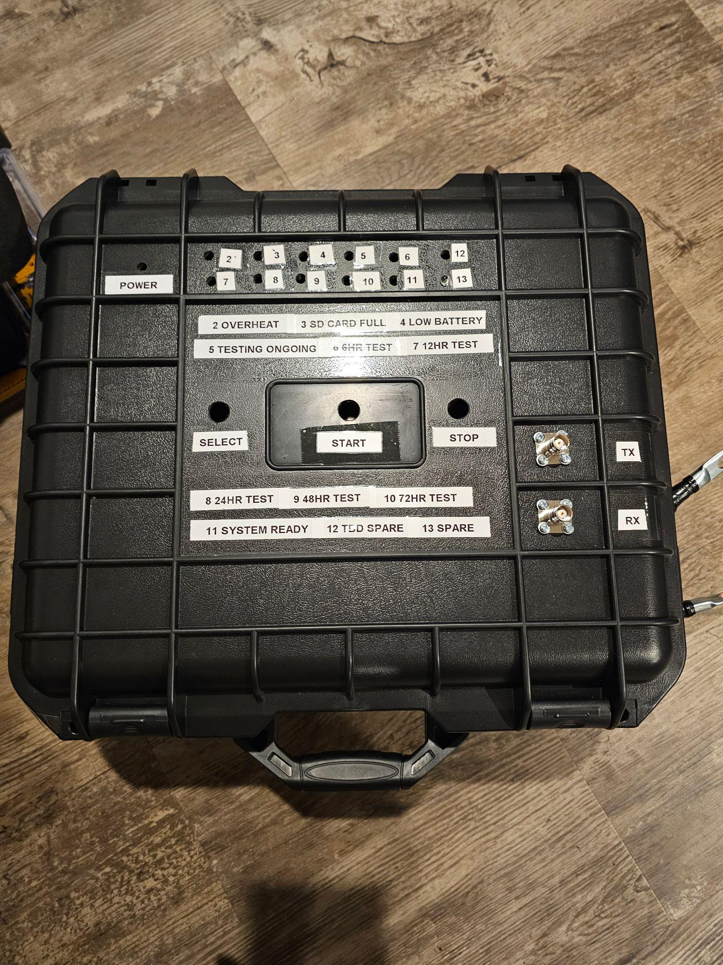

## Hardware Interfaces

The PUD hardware has several input commands given by pushbuttons to interface with the Raspberry Pi pico which controls the testing procedure and writes the results to a removable hardware storage device (SD card). Which then interacts with Matlab (similar to file format this is subject to change) to produce the desired result.

### REQ 3.2.1 The push buttons(select, start and stop) shall input 5v command signals to the Raspberry Pi

### REQ 3.2.2 The Raspberry Pi Pico shall send a switching signal to the MOSFET to gate the 500v input on and off. The signal shall be sent 50 times during a testing period then wait 10 minutes.

### REQ 3.2.3 The Raspberry Pi Pico shall send PWM or digital switching signals to the cooling fan to control its speed and on/off status.

### REQ 3.2.4 The Raspberry Pi Pico shall send commands to the status and alarm LEDs to turn on or off

### REQ 3.2.5 The ADC chip shall receive inputs from the transducer receiver.

### REQ 3.2.6 The Raspberry Pi Pico shall send commands to the SD card to record the received signal.

### REQ 3.2.7 The SD card will store data and be kept in a computer and matlab readable format.

**REQ 3.2.8** A laptop separate from the PUD shall run the Matlab software required to analyze the raw data.

## Software Interfaces

The PUD system has one operating software system running on a Raspberry Pi pico unit. Then later in the process a laptop running Matlab is used to process the data retrieved from the test.

### REQ 3.3.1 Raw data from the receiving transducer shall be sent to SD card using .mat format.

### REQ 3.3.2 Laptop shall be running Windows 10 or later.

**REQ 3.3.3** Laptop shall have Thonny and MATLAB installed.

## Communications Interfaces

This section does not strongly apply to this unit as it does not contain any form of inter-device communications in a wireless form. However there are two common communication interfaces for the hardware. This consists of the SPI bus and a UART system.

**REQ 3.4.1**  The Raspberry Pi Pico will use the SPI bus to move data between internal components.

**REQ 3.4.2**  The Raspberry Pi Pico will use the UART system to allow for programming and system updates.

# System Features

Section 4 provides amplifying information on the system functions discussed in section 2.2.

## System test pulse generation and reception

4.1.1 Description and Priority

The PUD system’s main function is to provide the transducer with the pulse required to generate a testing frequency which propagates through the test material and is received by a second receiving transducer and returned as a voltage to the system and recorded. High

4.1.2 Stimulus/Response Sequences

After the user powers on the unit and selects a test duration, then the start test button is pressed.

The unit will then save results to the SD card over the course of the test duration. Which the user can then take after the test completes or the user stops the test early.

4.1.3 Functional Requirements

**REQ 4.1.3.1** The electrical system shall be able to produce a 500 V 2µsec pulse.

**REQ 4.1.3.2** The control system shall be able to gate the test signal on and off within 2µsec.

**REQ 4.1.3.3** The system shall be able to produce 50 test signals with 100µsec interval between the test pulses.

**REQ 4.1.3.4** The system shall convert the analog signal received from the receiver transducer into a digital signal which can be recorded.

**REQ 4.1.3.5** The system shall be able to save the data received from the receiving transducer to a SD card.

**REQ 4.1.3.6** The system shall have greater than or equal to 35 GB of storage space to store test data.

## System self-regulation/ protection for overheat

4.2.1 Description and Priority

The PUD system performs self-monitoring of its internal temperature and activates the cooling systems to protect itself from entering failure conditions(131-140°F depending on the component). Shutting down if unable to correct the issue within 5 min to protect the system.

4.2.2 Stimulus/Response Sequences

No operator action required.

The internal temperature is detected to be approaching 131°F. This triggers the cooling fan to activate at a rate of revolutions per minute in accordance with a pre-programmed hysteresis curve (as seen in Figure 4) and cool the unit with ambient air from the unit’s surroundings.

4.2.3 Functional Requirements

**REQ 4.2.3.1** The system shall be able to monitor internal temperatures within the unit.

**REQ 4.2.3.2** The system shall run the cooling fan via pulse-width modulation in accordance with a pre-programmed hysteresis curve.

**REQ 4.2.3.3** The system shall shut down in the event that temperatures cannot be reduced below the danger level.

## System alarm system

4.3.1 Description and Priority

The system shall monitor for various failure conditions and alert the user to any detected abnormalities. This includes overtemperature, SD card full, and low battery. Low

4.3.2 Stimulus/Response Sequences

No user input required

Overheat, SD card Full, or low battery event occurs.

The system will illuminate a LED on the alarm panel to alert the user.

4.3.3 Functional Requirements

**REQ 4.3.3.1** The system shall be able to monitor internal unit temperature.

**REQ 4.3.3.2** The system shall turn power on for the overheated LED on the alarm panel if temperature exceeds or is equal to 125°F for more than 1 min.

**REQ 4.3.3.3** The system shall shut down if temperature exceeds or is equal to 130°F for more than 30 seconds.

**REQ 4.3.3.4** The system shall be able to monitor SD card status.

**REQ 4.3.3.5** The system shall power on if no SD card is inserted and flash the “SD Card Full” and “Power” LEDs if the card is not present.

**REQ 4.3.3.6** If no SD card is present, the machine shall not perform the test phase.

**REQ 4.3.3.7** The system shall turn power on for the SD card full LED on the alarm panel if the SD card is 95% of max storage capacity.

**REQ 4.3.3.8** The system shall record over the oldest data on the SD card if the error is not corrected.

**REQ 4.3.3.9** The system shall be able to monitor battery voltage.

**REQ 4.3.3.10** The system shall turn power on for the low battery LED on the alarm panel if the battery voltage drops to or below 10.5V

**REQ 4.3.3.11**  The system shall turn off the system if battery voltage is below 10V for greater than 1 min.

## After test processing

4.4.1 Description and Priority

The programs used to process the data retrieved from the PUD unit SD card. Making the raw data useful and displaying it in a useful format for analysis.

4.4.2 Stimulus/Response Sequences

Sd card is placed in laptop used for processing and analyzed using Matlab

4.4.3 Functional Requirements

**REQ 4.4.3.1** SD Card slot shall be protected by an external cover that requires external action to open

**REQ 4.4.3.2** SD Card shall contain a locking latch mechanism

**REQ 4.4.3.3** SD Card slot shall present an alignment guide to ensure proper insertion

# Other Nonfunctional Requirements

Section 5 consists of requirements and regulations other than the ones stated in previous sections.

## Performance Requirements

The system shall operate for 48 to 72 hours without recharging the internal battery

The system shall have fans and thermal monitoring to ensure components do not overheat in accordance with (IAW) applicable component requirements.

## Safety Requirements

### The system shall have an external safety lock to protect the user from high voltages present within.

### The system shall have a warning posted on the outside to alert the user to secure power and wait 40 minutes prior to opening due to risk of shock from high voltage supply and capacitor bank.

The safety lock shall be electrically isolated from any of the high voltage components to prevent shock.

## Security Requirements

The project has no security requirements as the data is not sensitive or private.

## System Quality Attributes

### All system components shall be tested prior to installation

### The system when fully constructed shall be tested using a test plan.

A parts list shall be provided along with the finished product to the user.

## Business Rules

Only personnel who have read the operating manual should operate the equipment.

# Other Requirements

## The case shall be able to withstand a fall from 3 ft and protect the contents of the case

The case shall be water resistant and be able to protect the contents from water penetration from rain

The electrical distribution system shall not exceed a component's rated limits, as shown in its related datasheet.

The electrical system shall have no faulty components.

The electrical system shall produce 5,12, and 500V DC.

The electrical system shall have sheathing protection.

The electrical system components shall be securely mounted to the casing.

The electrical system shall have no unintended paths to ground.

**Appendix A: Glossary**

|  |  |
| --- | --- |
| **Abbreviation** | **Full spelling** |
| LED | Light emitting diode |
| MOSFET | Metal-oxide-semiconductor field-effect transistor |
| PUD | Portable Ultrasound Device |
| Rx | Rx- Receiver |
| Tx | Tx- Transmitter |
| SD | Secure Digital card |
| IAW | In accordance with |
|  |  |

**Appendix B: Analysis Models**

Figure 4: Cooling fan behavior vs temperature

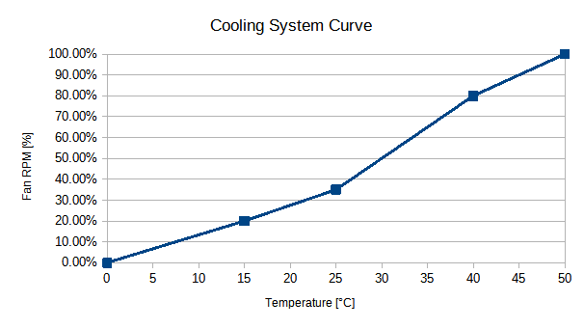

Figure 5: Electrical system schematic diagram

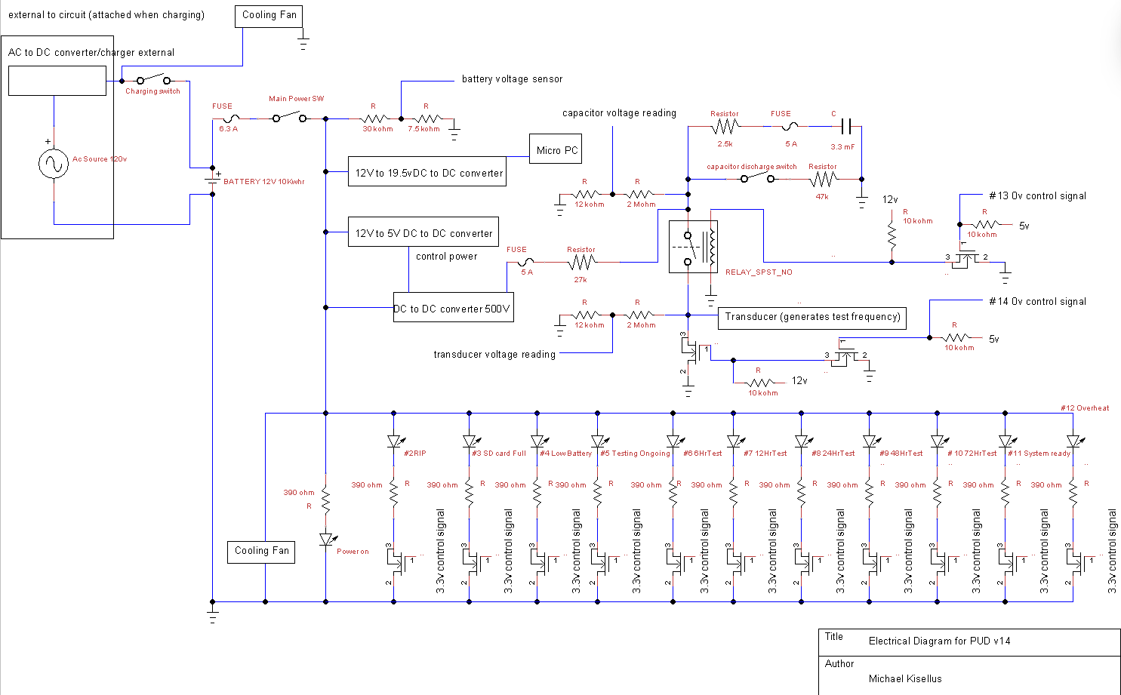

**Appendix C: Reference**

“021706.3TXP Littelfuse Inc. | Circuit Protection | DigiKey.” *DigiKey*, www.digikey.com/en/products/detail/littelfuse-inc/021706-3TXP/3425317. Accessed 21 Oct. 2023.

“05200005ZXGY Littelfuse Inc. | Circuit Protection | DigiKey.” *DigiKey*, www.digikey.com/en/products/detail/littelfuse-inc/05200005ZXGY/554334. Accessed 21 Oct. 2023.

“0ADKC5000-Be Bel Fuse Inc. | Circuit Protection | Digikey.” *DigiKey*, www.digikey.com/en/products/detail/bel-fuse-inc/0ADKC5000-BE/7404459. Accessed 21 Oct. 2023.

“100ft - 1/2 Inch Pet Expandable Braided Sleeving - Amazon.Com.” *Amazon*, www.amazon.com/100ft-Expandable-Braided-Sleeving-braided/dp/B074GMNW7T. Accessed 21 Oct. 2023.

“12-48V Battery Isolator Switch for Car Vehicle RV and Marine (on/off): Eco-Worthy.” *ECO*, www.eco-worthy.com/products/12-48v-battery-isolator-switch-for-car-vehicle-rv-and-marine-on-off?variant=40589578567868. Accessed 21 Oct. 2023.

“2-1546306-1 TE Connectivity AMP Connectors - DigiKey Electronics.” *DigiKey*, www.digikey.com/en/products/detail/te-connectivity-amp-connectors/2-1546306-1/1136667. Accessed 21 Oct. 2023.

“330 PCS M2 Male Female Brass Hex Spacer Standoffs Screws ... - Amazon.Com.” *Amazon*, www.amazon.com/Standoffs-Assortment-Threaded-Circuit-Motherboard/dp/B0BZYTC581. Accessed 21 Oct. 2023.

“577002B00000G Aavid, Thermal Division of Boyd Corporation - Digikey.” *DigiKey*, www.digikey.com/en/products/detail/aavid-thermal-division-of-boyd-corporation/577002B00000G/102507. Accessed 21 Oct. 2023.

“5A 12V Automatic Smart Battery Charger and Maintainer with LCD Display for Lead Acid and Lithium (LiFePO4) Batteries: Eco-Worthy.” *ECO*, www.eco-worthy.com/products/5a-12v-automatic-smart-battery-charger-and-maintainer-with-lcd-display-for-lead-acid-and-lithium-lifepo4-batteries?variant=42350017052921. Accessed 21 Oct. 2023.

“6AWG (16mm2) 13 Inch Battery Interconnect Cable: Eco-Worthy.” *ECO*, www.eco-worthy.com/products/6awg-16mm-13-inch-battery-interconnect-cable?variant=34593133625509. Accessed 21 Oct. 2023.

“Als30a332np500 Kemet | Capacitors | Digikey - Digi-Key Electronics.” *Digikey*, www.digikey.com/en/products/detail/kemet/ALS30A332NP500/3462159. Accessed 21 Oct. 2023.

“Amazon.Com: 2Pcs Electronic Thermostat Controller W1209 DC 12V Digital ...” *Amazon*, www.amazon.com/Electronic-Thermostat-Controller-Waterproof-Temperature/dp/B08Y6L34PX. Accessed 4 Feb. 2024.

“Amazon.Com: Tsa Approved Luggage Locks, Travel Locks Which Also Work ...” *Amazon*, www.amazon.com/Approved-Luggage-Travel-Toolbox-Backpack/dp/B07MVJZ6C2. Accessed 4 Feb. 2024.

“Amazon.Com: XHF 3/4" Strong Back-Glue Self Adhesive Black Cable Zip Tie ...” *Amazon*, www.amazon.com/XHF-Back-Glue-Protection-Fasteners-Management/dp/B08F77YVYB. Accessed 21 Oct. 2023.

“ANCOR Marine Grade Primary Wire and Battery Cable - Amazon.Com.” *Amazon*, www.amazon.com/Ancor-Marine-Grade-Primary-Battery/dp/B07ZSDK651. Accessed 21 Oct. 2023.

“ANSI Z535 Safety Labels - Hazardous Voltage Inside.” *Seton*, www.seton.com/ansi-z535-safety-labels-hazardous-voltage-inside-l5476.html?utm_campaign=%5BNB%5D_Labels_Catch%2BAll_PLA-S_High_All_PC-02_GGL_SUS&utm_source=google&utm_medium=cpc&utm_term=&matchtype=&device=c&adgroupid=&gclsrc=aw.ds&gclid=CjwKCAjwseSoBhBXEiwA9iZtxo15KyzhNfMKE5oyzbC-vorhbGmpge9ewSppeK7ReCrhPLgh6Yt0NRoCVhcQAvD_BwE. Accessed 21 Oct. 2023.

“ASEV30-B Altran Magnetics, LLC | Relays | Digikey.” *DigiKey*, www.digikey.com/en/products/detail/altran-magnetics-llc/ASEV30-B/14120027. Accessed 4 Feb. 2024.

“C503C-Wan-CCADB232 Creeled, Inc. | Optoelectronics | DigiKey.” *DigiKey*, www.digikey.com/en/products/detail/creeled-inc/C503C-WAN-CCADB232/2681196. Accessed 21 Oct. 2023.

“CF12JT390R Stackpole Electronics Inc | Resistors | Digikey.” *DigiKey*, www.digikey.com/en/products/detail/stackpole-electronics-inc/CF12JT390R/1741140. Accessed 21 Oct. 2023.

“DC 12V 24V to 5V Step down Converter Regulator 5A 25W Power Adapter ...” *Amazon*, www.amazon.com/Converter-Regulator-Adapter-Reducer-Electronics/dp/B07Q5W1BG3. Accessed 21 Oct. 2023.

“Dolby Vision + Dolby Atmos - Amazon.Com.” *Amazon*, www.amazon.com/Hisense-Premium-50U6G1-Quantum-Compatible/dp/B09TWYDMPY. Accessed 4 Feb. 2024.

“E/Fusing 900 Moldable Silicone Putty - Black - Amazon.Com.” *Amazon*, www.amazon.com/E-FUSING-900/dp/B0B6JWT295. Accessed 4 Feb. 2024.

“High Voltage Power Supply AHV12V500V20MAW Analog Technologies | Power ...” *DigiKey*, www.digikey.com/en/products/detail/analog-technologies/High-Voltage-Power-Supply-AHV12V500V20MAW/18621897. Accessed 21 Oct. 2023.

“HTTPS: //WWW. Amazon. COM/GP/Product/B00955337I/Ref=oh_aui_detailpage ...” *Amazon*, www.amazon.com/gp/customer-reviews/R2WSHBZW6W1Z0K/. Accessed 4 Feb. 2024.

“HTTPS: //WWW. Amazon. COM/GP/Product/B00955337I/Ref=oh_aui_detailpage ...” *Amazon*, www.amazon.com/gp/customer-reviews/R2WSHBZW6W1Z0K/. Accessed 4 Feb. 2024.

“LiFePO4 12V 50ah Lithium Iron Phosphate Battery: Eco-Worthy.” *ECO*, www.eco-worthy.com/products/lifepo4-12v-50ah-lithium-iron-phosphate-battery?currency=USD&variant=42491122712825&utm_medium=cpc&utm_source=google&utm_campaign=Google+Shopping&stkn=ac7b7d784bf0&gclid=CjwKCAjwgsqoBhBNEiwAwe5w02e_e41oUWis8aF0zZ64SqB2gfhDZQGvhFikRSAGGwQNgwVP8l8POBoCaacQAvD_BwE. Accessed 21 Oct. 2023.

“Miuzei PCB Board Prototype Kit for Electronic Projects, Circuit Solder ...” *Amazon*, www.amazon.com/Miuzei-Including-Prototype-Connector-Terminal/dp/B07PS4VCDD. Accessed 21 Oct. 2023.

“Ohmite Distributor | DigiKey Electronics.” *DigiKey*, www.digikey.com/en/supplier-centers/ohmite. Accessed 21 Oct. 2023.

“PMV16XNR Nexperia USA Inc. | Discrete Semiconductor Products | DigiKey.” *DigiKey*, www.digikey.com/en/products/detail/nexperia-usa-inc/PMV16XNR/5395791. Accessed 21 Oct. 2023.

“Ra-T2X-38E Ohmite | Fans, Thermal Management | DigiKey.” *DigiKey*, www.digikey.com/en/products/detail/ohmite/RA-T2X-38E/2416488. Accessed 21 Oct. 2023.

“SBBSM2106-1 Chip Quik Inc. | Prototyping, Fabrication Products | DigiKey.” *DigiKey*, www.digikey.com/en/products/detail/chip-quik-inc/SBBSM2106-1/5978238. Accessed 21 Oct. 2023.

“Starelo 5pcs 12mm Momentary Push Button Switch Black Shell with Pre ...” *Amazon*, www.amazon.com/Momentary-Push-Button-Switch-Without/dp/B09BKZ68HF. Accessed 21 Oct. 2023.

“STF19NM50N Stmicroelectronics | Discrete Semiconductor Products | DigiKey.” *DigiKey*, www.digikey.com/en/products/detail/stmicroelectronics/STF19NM50N/2346299. Accessed 21 Oct. 2023.

“TE120B2K7J Te Connectivity Passive Product | Resistors | DigiKey.” *DigiKey*, www.digikey.com/en/products/detail/te-connectivity-passive-product/TE120B2K7J/14308543. Accessed 21 Oct. 2023.

“TMP37FT9Z Analog Devices Inc. | Sensors, Transducers | DigiKey.” *DigiKey*, www.digikey.com/en/products/detail/analog-devices-inc/TMP37FT9Z/1217626. Accessed 4 Feb. 2024.